Lab 2: Containerization & Orchestration — Docker / Podman Network
Lab Report — Inter-Container Communication, Custom Bridge Networks, IP & DNS Resolution
Student Name: | Sarvesh Chandran
Roll Number: | 2301730032
Course & Faculty: | DevOps Lab (ENSP461) — Prof. Amit Kumar Singh
Target System: | oveRthinkLM Recursive Engine & Sandbox (FastAPI + Redis)
GitHub Repository: | https://github.com/Sarveshero3/oveRthinkLM

1. Objective
To demonstrate and document container networking principles within the oveRthinkLM ecosystem:
1. Create and inspect a custom user-defined bridge network with automatic embedded DNS service discovery.
2. Deploy interconnected containers (FastAPI engine and Redis state store) attached to the custom network.
3. Validate direct inter-container communication using container IP addresses.
4. Validate automatic name resolution and inter-service communication using container DNS names.
2. Part A: Network Architecture & Custom Bridge Creation
Step A.1: List Local Networks
Listing active networks displays the default 'podman' bridge driver before provisioning our custom cluster network.
podman network ls
Output / Execution Screenshot:
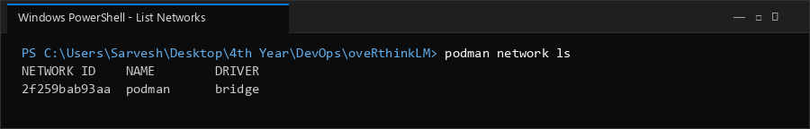

Step A.2: Create and Inspect User-Defined Bridge Network
A user-defined bridge network 'overthink-cluster-net' is created. Inspection confirms subnet allocation (10.89.0.0/24), default gateway (10.89.0.1), and active embedded DNS resolution (dns_enabled: true).
podman network create overthink-cluster-net
podman network inspect overthink-cluster-net
Output / Execution Screenshot:
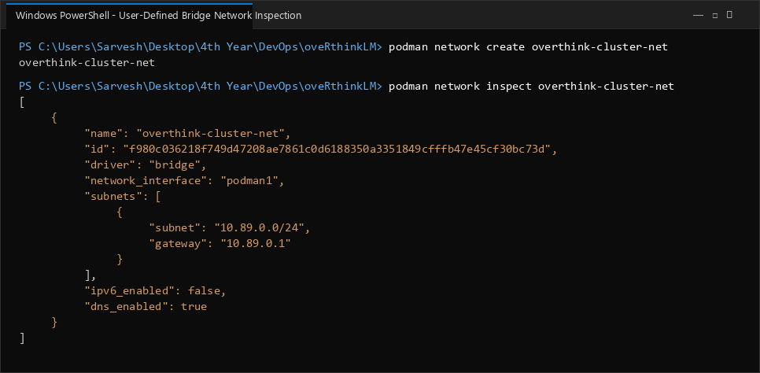

3. Part B: Multi-Container Deployment on Custom Network
Step B.1: Run Redis and Engine Containers Attached to Custom Network
Both microservices are attached to 'overthink-cluster-net'. The engine receives REDIS_HOST configured as the peer container name.
podman run -d --name overthink-redis-net --network overthink-cluster-net redis:alpine
podman run -d --name overthink-engine-net --network overthink-cluster-net -e REDIS_HOST=overthink-redis-net -p 8000:8000 overthink-engine:1.0
podman ps
Output / Execution Screenshot:
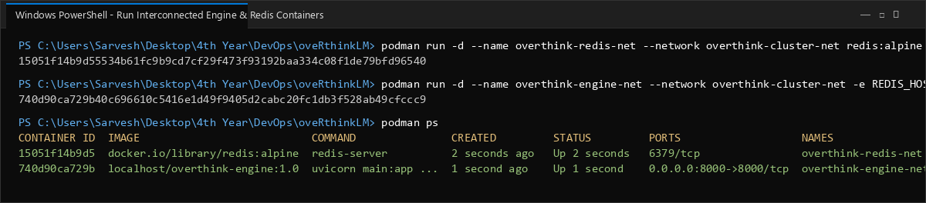

Step B.2: Inspect Assigned Container IP Addresses
Inspection reveals dynamically allocated IP addresses on the 10.89.0.0/24 subnet: Redis is assigned 10.89.0.2, and Engine is assigned 10.89.0.3.
podman inspect overthink-redis-net --format "{{json .NetworkSettings.Networks}}"
podman inspect overthink-engine-net --format "{{json .NetworkSettings.Networks}}"
Output / Execution Screenshot:
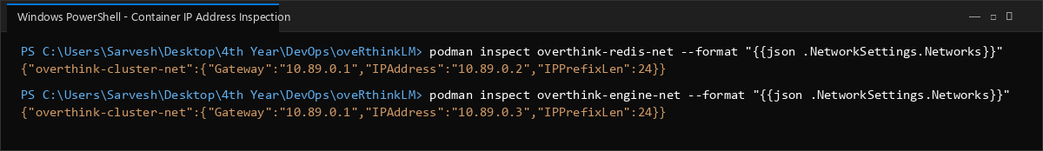

4. Part C: Communication via IP Address and Container Name
Step C.1: Inter-Container Communication via Direct Container IP Address
From inside 'overthink-engine-net' (10.89.0.3), a TCP connection is established directly to Redis IP 10.89.0.2:6379. Redis responds with PONG (True).
podman exec overthink-engine-net python3 -c "import redis; r = redis.Redis(host='10.89.0.2', port=6379); print('Direct IP Ping to 10.89.0.2:6379 ->', r.ping())"
Output / Execution Screenshot:
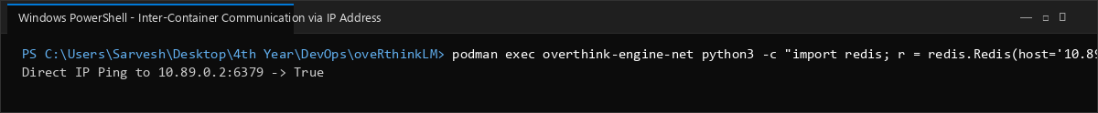

Step C.2: Inter-Container Communication via Container Name (Automatic DNS)
The embedded DNS server resolves 'overthink-redis-net' to 10.89.0.2 transparently. The Python client connects and successfully pings the Redis instance.
podman exec overthink-engine-net python3 -c "import redis; r = redis.Redis(host='overthink-redis-net', port=6379); print('DNS Name Ping to overthink-redis-net:6379 ->', r.ping())"
Output / Execution Screenshot:
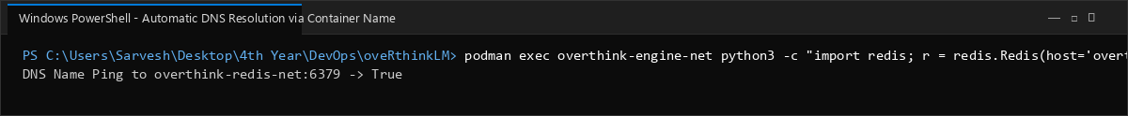

Step C.3: Engine REST API Status Verification Across Network
The host accesses the engine's /v1/status endpoint, confirming that the engine service successfully detected and connected to the Redis state store ('connected': true).
curl http://localhost:8000/v1/status
Output / Execution Screenshot:
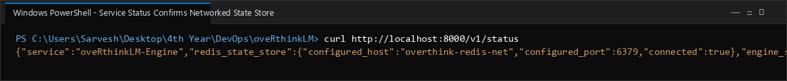

Step C.4: Graceful Network & Container Teardown
Both containers are terminated and removed, followed by the disposal of the custom bridge network without leaving orphaned network endpoints.
podman stop overthink-engine-net overthink-redis-net
podman rm overthink-engine-net overthink-redis-net
podman network rm overthink-cluster-net
Output / Execution Screenshot:
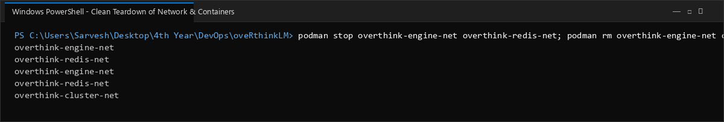

5. Network Topology & DNS Characteristics
Network Mode | Automatic DNS Resolution | Behavior & Security Implication
Default Bridge ('podman') | Disabled (IP only) | Containers can communicate only via explicit IP addresses; container name resolution fails unless legacy links are configured.
User-Defined Bridge | Enabled (Embedded DNS) | Provides isolated broadcast domain with built-in DNS service discovery by container name or network alias.
Host Network ('host') | N/A (Host namespace) | Disables container network isolation; container shares host ports directly, risking port collision.
6. Conclusion
Inter-container networking was validated across multiple communication modalities in oveRthinkLM:
• Custom user-defined bridge networks establish an isolated virtual subnet with secure layer-2/layer-3 boundaries.
• Embedded DNS service discovery enables containers to locate dependent services dynamically by container name, avoiding brittle hardcoded IP addresses.
• Seamless interoperability was confirmed between the FastAPI recursive language model engine and the Redis trajectory store.

